**[[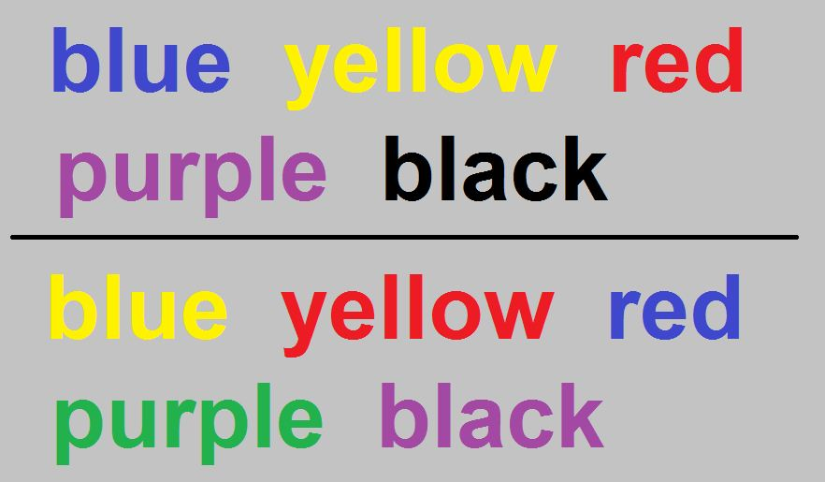](https://classroom.udacity.com/nanodegrees/nd002/parts/1ba6332a-d816-4b97-a32d-f4e684bf11ce/modules/66f6e2ae-c356-4f6f-bed5-73ca5613be95/lessons/33253220-6815-4099-be84-6baf201c56b5/concepts/40089447-6ccc-4f75-a2ff-8181ae118764)](https://classroom.udacity.com/nanodegrees/nd002/parts/1ba6332a-d816-4b97-a32d-f4e684bf11ce/modules/66f6e2ae-c356-4f6f-bed5-73ca5613be95/lessons/33253220-6815-4099-be84-6baf201c56b5/concepts/40089447-6ccc-4f75-a2ff-8181ae118764)**

**Project Overview**

In this project, you will investigate a classic phenomenon from experimental psychology called the [**Stroop Effect**](https://en.wikipedia.org/wiki/Stroop_effect). You will learn a little bit about the experiment, create a hypothesis regarding the outcome of the task, then go through the task yourself. You will then look at some data collected from others who have performed the same task and will compute some statistics describing the results. Finally, you will interpret your results in terms of your hypotheses.

If you need a refresher on statistics, you can take a free Statistics course from Udacity!

**Why this project?**

Statistics is a major component of data analysis. Understanding statistics allows you to investigate data and make inferences based on your observations. A foundation in statistics also allows you to be a critical consumer of analyses that others perform, as well as the conclusions they have drawn.

**What will I learn?**

This project will review the basic concepts of statistics, including:

* How to identify components of an experiment
* How to use descriptive statistics to describe qualities of a sample
* How to set up a hypothesis test, make inferences from a sample, and draw conclusions based on the results

### Project Instructions

#### Background Information

In a Stroop task, participants are presented with a list of words, with each word displayed in a color of ink. The participant’s task is to say out loud the color of the ink in which the word is printed. The task has two conditions: a congruent words condition, and an incongruent words condition. In the congruent words condition, the words being displayed are color words whose names match the colors in which they are printed: for example RED, BLUE. In the incongruent words condition, the words displayed are color words whose names do not match the colors in which they are printed: for examplePURPLE, ORANGE. In each case, we measure the time it takes to name the ink colors in equally-sized lists. Each participant will go through and record a time from each condition.

#### Questions For Investigation

As a general note, be sure to keep a record of any resources that you use or refer to in the creation of your project. You will need to report your sources as part of the project submission.

1. What is our independent variable? What is our dependent variable?

2. What is an appropriate set of hypotheses for this task? Specify the null and alternative hypotheses based on what you think the researchers might be interested in. Justify your choices.

Now it’s your chance to try out the Stroop task for yourself. In order to get a better understanding of the Stroop task works, try it out yourself [**here**](https://www.google.com/url?q=https://faculty.washington.edu/chudler/java/ready.html&sa=D&ust=1520800795856000&usg=AFQjCNFS72ighy5tj6cGPwBZgYreEl_zRg).

Now, you can answer these questions directly within the classroom on the previous page, or you can download the data from the resources to complete on your local machine.

3. Report some descriptive statistics regarding this dataset. Include at least one measure of central tendency and at least one measure of variability.

4. Provide one or two visualizations that show the distribution of the sample data. Write one or two sentences noting what you observe about the plot or plots.

5. Now, perform the statistical test and report your results. What is your confidence level or Type I error associated with your test? What is your conclusion regarding the hypotheses you set up? Did the results match up with your expectations? **Hint:** Think about what is being measured on each individual, and what statistic best captures how an individual reacts in each environment.

6. Optional: What do you think is responsible for the effects observed? Can you think of an alternative or similar task that would result in a similar effect? Some research about the problem will be helpful for thinking about these two questions!